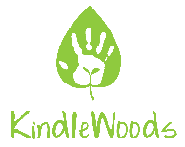
KindleWoods CIC
Social Audit Report Jan 2020-Jan 2021
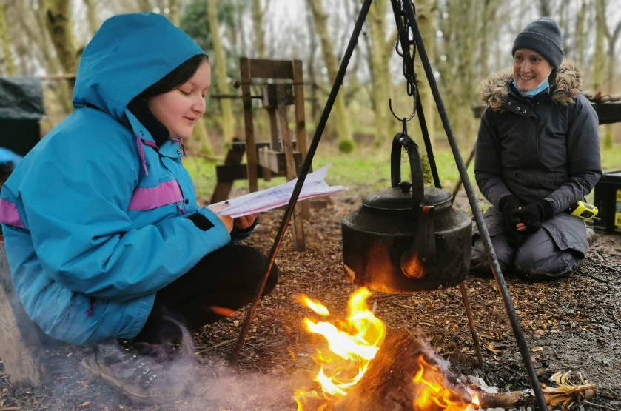

“It is thanks to this project and working for KindleWoods again that I came back out of hiding and began reintegrating back into the community. This has been a life saver to me and I will be forever grateful for helping me regain my confidence in myself, in my capabilities as a practitioner and in my competence as a human being.” KindleWoods Practitioner, 2021
The pandemic posed unique challenges to all in the sector and beyond, and we were no exception. Whilst there were many challenges both personally for participants and staff as well as professionally as a business, there were also incredible moments of hope and community, despite the isolation of lockdown. We are exceptionally proud of the creativity, perseverance and determination our team showed throughout the year and how we adapted often at very short notice to be able to support people in a meaningful way. We were particularly proud of the Kindling Community project, which took place over the winter months during the second and third lockdowns. With short days, cold weather and the continued uncertainty and restrictions around daily life, it was powerful and timely to be able to provide our participants with a window away from the pressure of the pandemic, supporting them out in the woods in their ‘bubbles’ with a space which helped to meet their wellbeing needs during that time. We shall remember the joy and gratitude of participants, who continued to come to the woods in all weather conditions.
“It is amazing to be out here. It’s -5, we’ve battled snow and ice to get here, but we are here, and we are actually making pizza on the campfire!” Woodland Wellbeing Participant, Jan 2021
As the stories and feedback in this report demonstrate, the work we did was important not just for our participants, but our staff too, providing them with a positive connection to community, nature and wellbeing; our three driving goals as an organisation.

Kindling Community Project
Funded by The National Lottery Community Fund
Summary;
With a team of 4 staff (1 full time, 3 part time) KindleWoods provided mental health support both on the ground and virtually between November 2020 and March 2021.
Activity:
In the woods; 40 unique participants and volunteers
During December we ran Woodland Wellbeing sessions, Volunteer conservation sessions and Campfire Mindfulness sessions, averaging 5 half day sessions per week. During the conservation sessions volunteers helped us to plant 100 trees and thin out half an acre of woodland. We worked with individuals new to the project and those who had accessed support before. During January, February and March we offered intensive support to bubbles for individuals experiencing mental health distress during lockdown, as well as 1-1 walks for individuals unable to access the woods.
Virtually and on the phone; 10 participants and volunteers
During December we worked with participants virtually, providing telephone, text and email support. We also worked with volunteers who created a ‘care package project’, where volunteers handmade candles, drop spindles, ‘inspirational’ tea bags, and relaxation pouches for people experiencing particular distress due to the pandemic. During January, February and March we continued to offer online support.
Through care package support; 25 unique participants received support from us in January, February and March through our care package box scheme (more details below).

Woodland Wellbeing
Feedback and photographs
We worked with both new participants and participants who have previously attended KindleWoods sessions. Many described how the pressures of the pandemic had caused a worsening of symptoms (some of which is detailed below in our stakeholder consultation). We adapted our delivery during the pandemic, initially working with small groups and then as we went into lockdown, working more intensively with often 2 or 3 individuals in their bubbles.
“Being in nature, in a safe space with understanding people & getting to learn a new skill were very therapeutic on a deep level" Woodland Wellbeing Participant Dec 2020
“It’s been a lifesaver during lockdown. I’d begun to feel so disconnected, I started hallucinating at one point. Being able to get out into the fresh air, do some activity and see a couple of people (at a safe distance) does wonders for my mood. As someone with mental health issues, lockdown has been a nightmare.” Bubble participant, Jan 2021
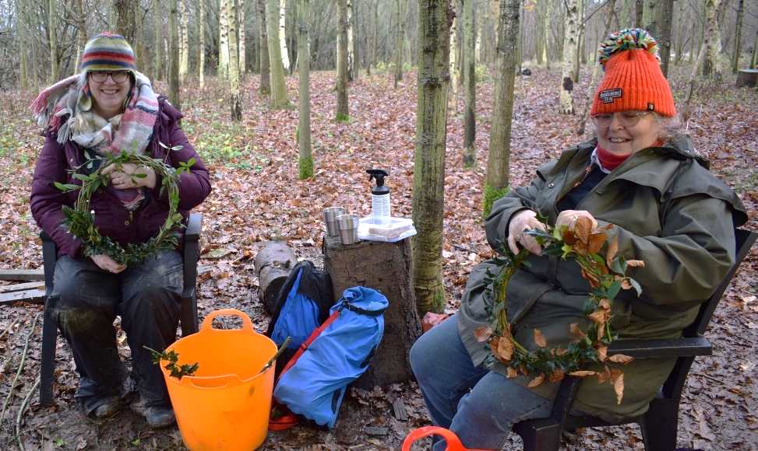

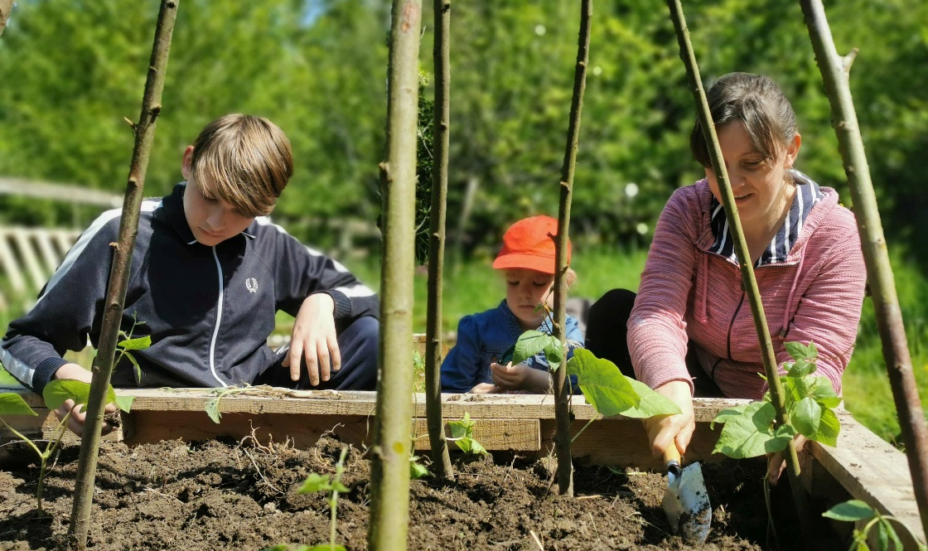

Intensive support for bubbles for those experiencing mental health distress during lockdown
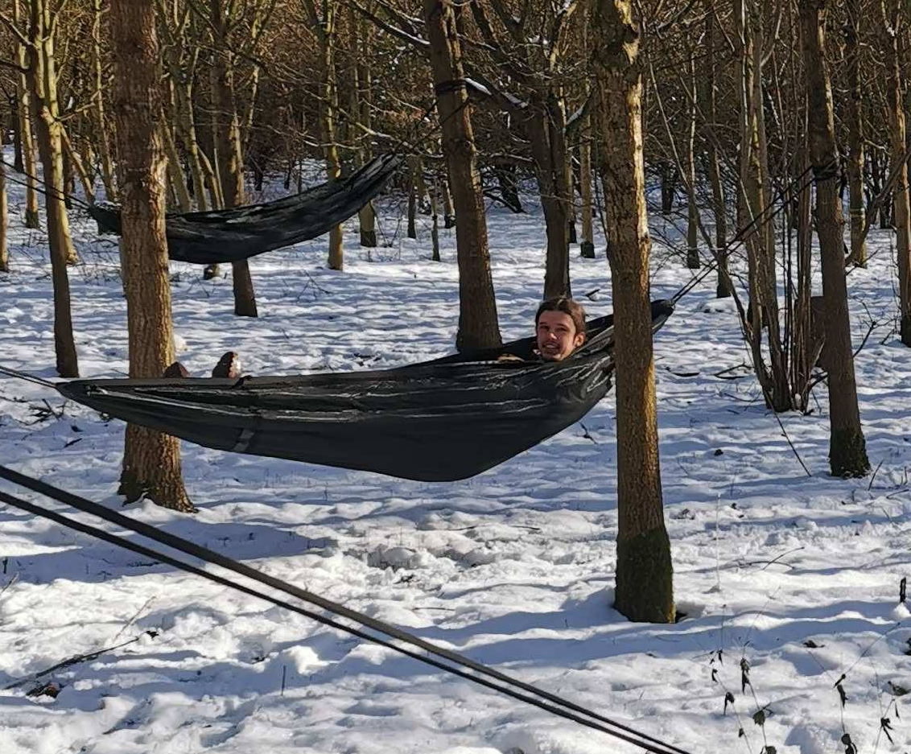
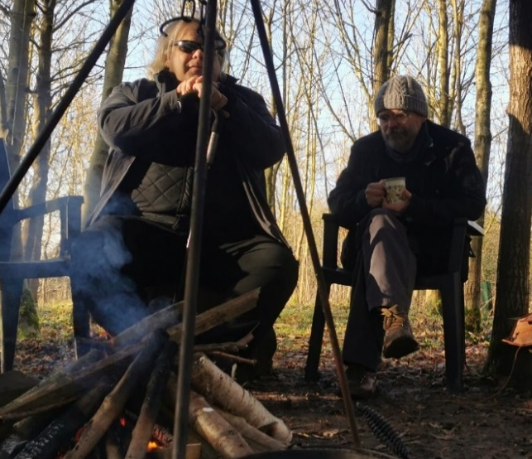
Participant Case Study
In December 2020 we started working with a woman experiencing depression and anxiety who was also carer for her two autistic children who were struggling badly with school prior to the pandemic. The pandemic intensified the mental ill health of the two children, particularly her son, who was self-harming, experiencing suicidal ideation and extreme anger. She arrived at the volunteer group one morning particularly distressed and after a chat we asked if she thought her son might benefit from some sessions. She thought it was an excellent idea, so we worked on making the project accessible and suitable for him. After four weeks at the sessions, she sent me an email which she has asked us to share;
“He told his psychiatrist and the social worker last week that kindlewoods is better than therapy! This makes him feel good, it’s what he’s been missing – being active and to have his brain involved in interesting things. He feels understood too.
I don’t know what we’d have done without it. I was so depressed before, worrying about how to cope during the pandemic with all the problems at school. Now I can bring him here, I feel like I can keep going, it’s something to look forward to. He came away from the session last week happy! It’s the first time I’ve seen him like that in ages. Usually we have to have the music off in the car on the way home from trips out as it's too much for him. Today he put it on as we drove off, turned it up and sung along!! He stayed happy for the rest of the day too! He's been talking about kindlewoods so much.
It also did me a lot of good. I actually picked up some crochet this afternoon and enjoyed it! I haven't felt like doing any craft stuff since things started going wrong with school. I made myself do a little bit over Christmas but didn't enjoy it. This afternoon I realised I really fancied having a go again. I had a lovely hour sat crocheting and actually enjoyed it. Thank you so so much.

Other participant feedback
“The woods are a relaxing place to be away from anything too frantic and with other people who understood why I might not feel like talking, might not feel like joining in, might just be happy to be outside and be left alone. Things to do if I feel like it, either on my own or with someone. If not then I can sit back and watch without being judged for it. The most useful thing for me apart from getting out was the non-judgment part. It meant that for me there was no anxiety about going to a session.” Bubble participant, Jan 2021

“It was just really nice to sit together with like minded people, engaging in positive conversations, supporting and encouraging each other. There was a sense of 'we are in this together', which is so important in these times where we all try to stay away from everyone.”
Woodland Wellbeing Participant, Jan 2021

“Everyone feels relaxed and we can talk about anything we want to talk about, whether or not its random silly stuff, or more in depth , that’s comfortable to do that as well. Or just not saying much at all, if it’s a bad day, that’s okay too.” Woodland Wellbeing participant Dec 2021
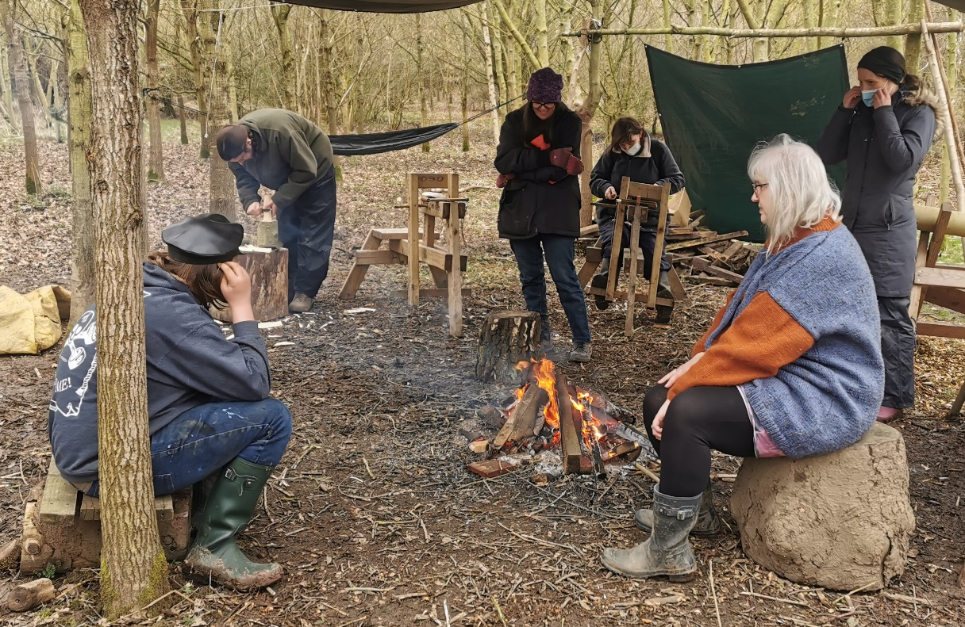

Buddy Walk Scheme
We also started a buddy walk scheme, to support two individuals who were completely unable to access our services on the ground and we recognised it was becoming increasingly vital for them to have some form of normal human interaction. We started with a staff member providing this service, and then created the necessary volunteer policies and safeguards and recruited a volunteer to support with this role.
Wellbeing boxes
We were incredibly proud of the wellbeing boxes which our volunteers beautifully handmade using natural and recycled materials where possible. We advertised these locally and individuals were able to nominate people who were in need of a wellbeing boost to receive them. The feedback we had was overwhelmingly positive, with individuals describing how it brightened their week, making them feel cared for during a particularly difficult time in the pandemic.
“I can’t tell you how lovely it was to arrive home and find the parcel. Under any circumstances it would be a real treat, but (due to the circumstances) it was extra special”
“Thankyou so much for sending the package to (anonymous). It has been dreadful for them recently, and it was lovely to be able to do something which made them feel loved”
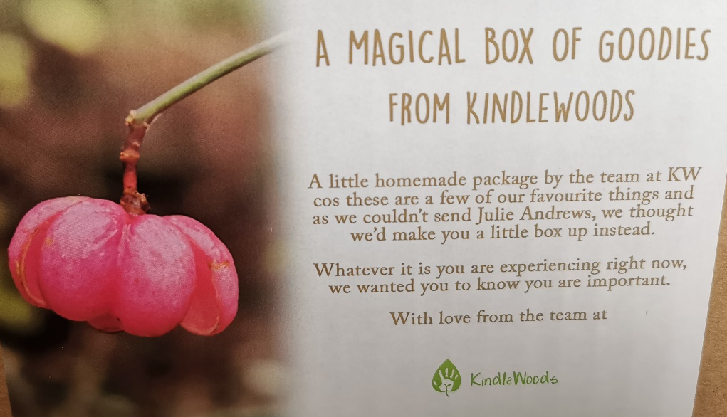
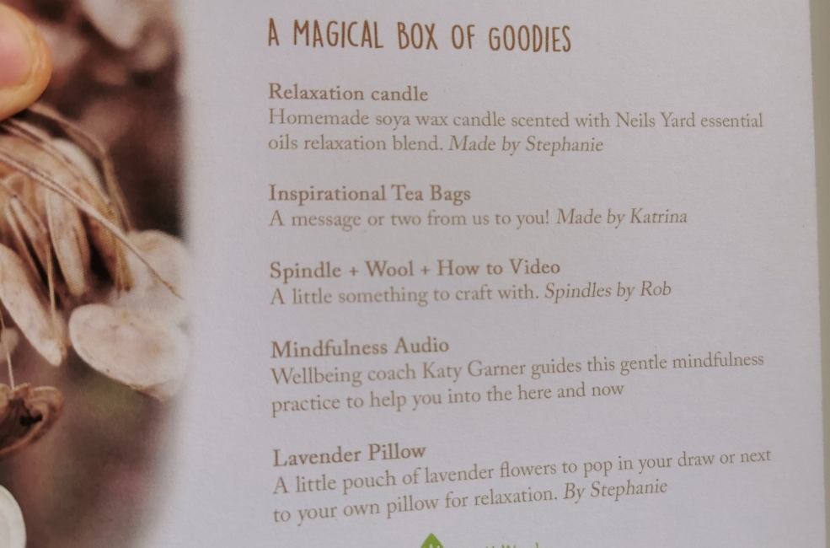
Our wellbeing boxes.

Woodland Management
As part of the Kindling Community Project KindleWoods ran conservation volunteer sessions each week initially in York and then in Thirsk between December and March. In York we supported thinning the woods, using hand tools to fell small trees which were then added to the dead hedge at the back of the site. We also laid two hedgerows in North Yorkshire totalling 400 metres, planted 600 trees (100 by volunteers), and coppiced ¼ of an acre of hazel.
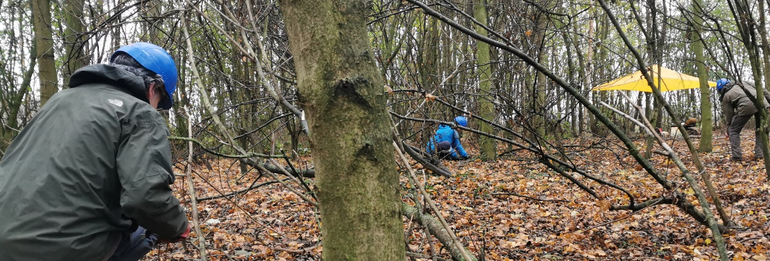
Thinning trees in the woods at Rawcliffe Country Park, York as part of the Kindling Community Project, Dec 2020

“It eased the social anxiety that 2020 has triggered, & gave me confidence that I am not alone” Volunteer Dec 2020

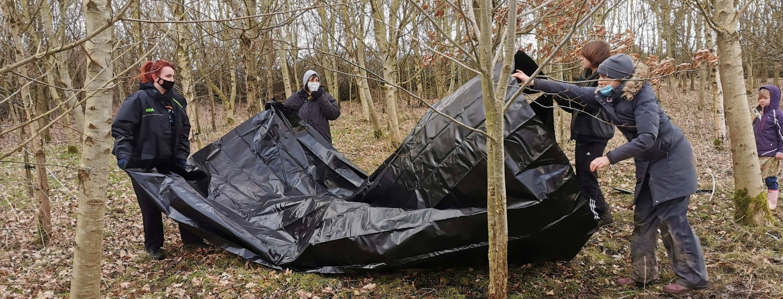
Designing a pond area at the woods in Thirsk as part of the Kindling Community Project

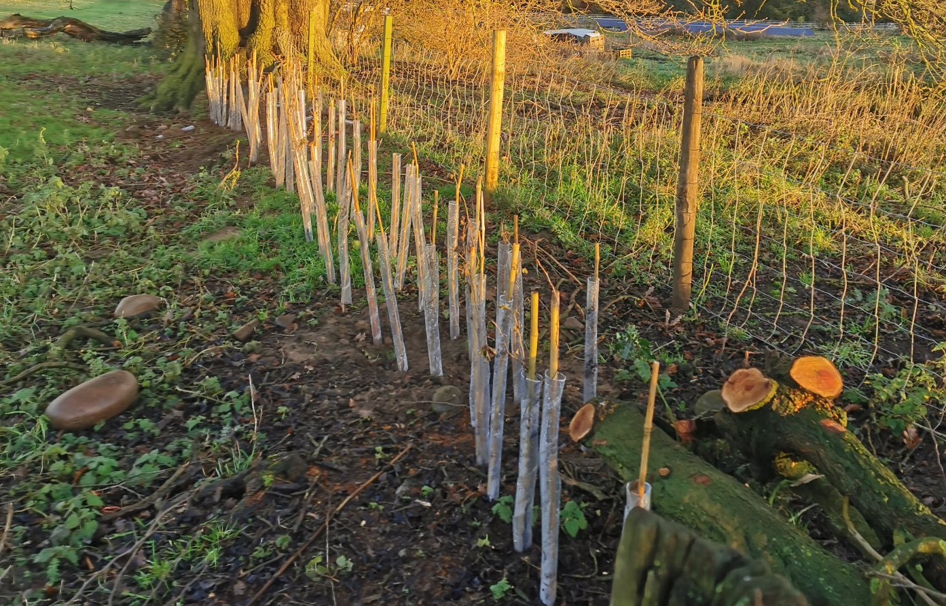
Planting 600 hedgerow trees in bare gaps, Nov 2021

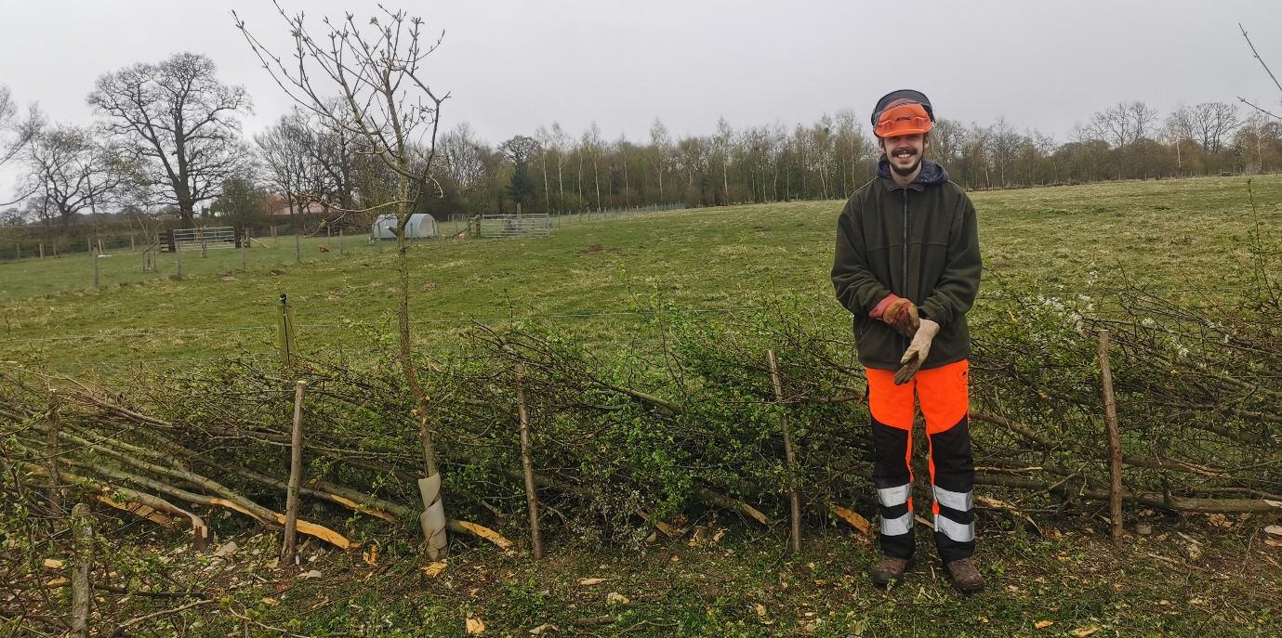
Josh learning how to lay lancashire and westmoreland style with Andrew Kirkwood

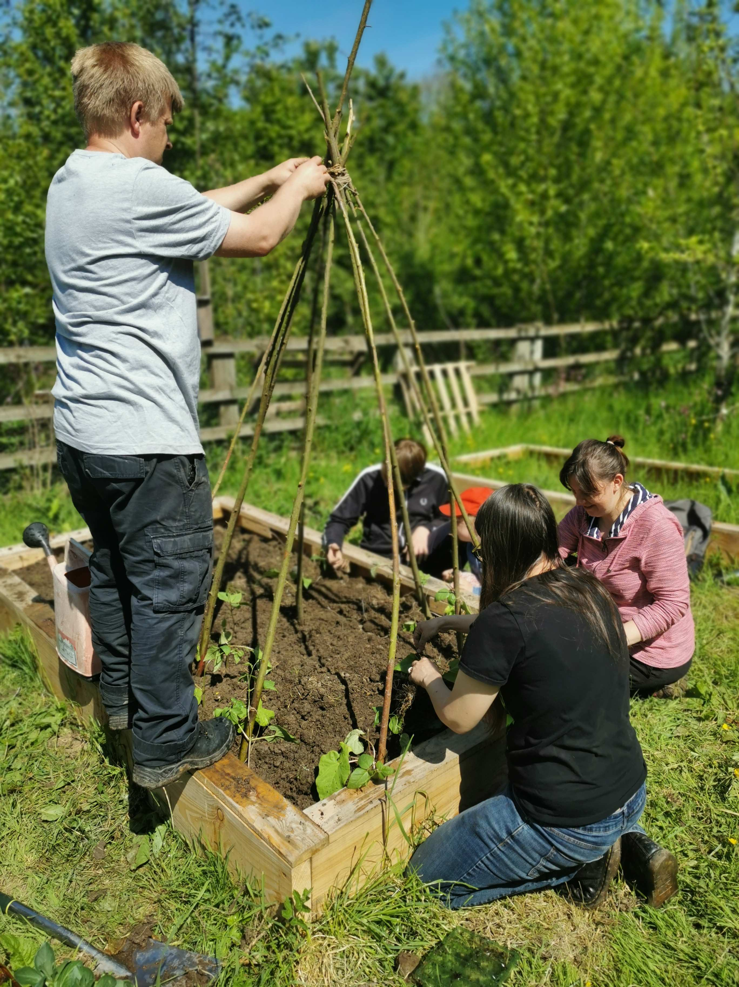
As part of the Kindling Community Project, participants built planters, and grew vegetables and a herb garden at the woods.

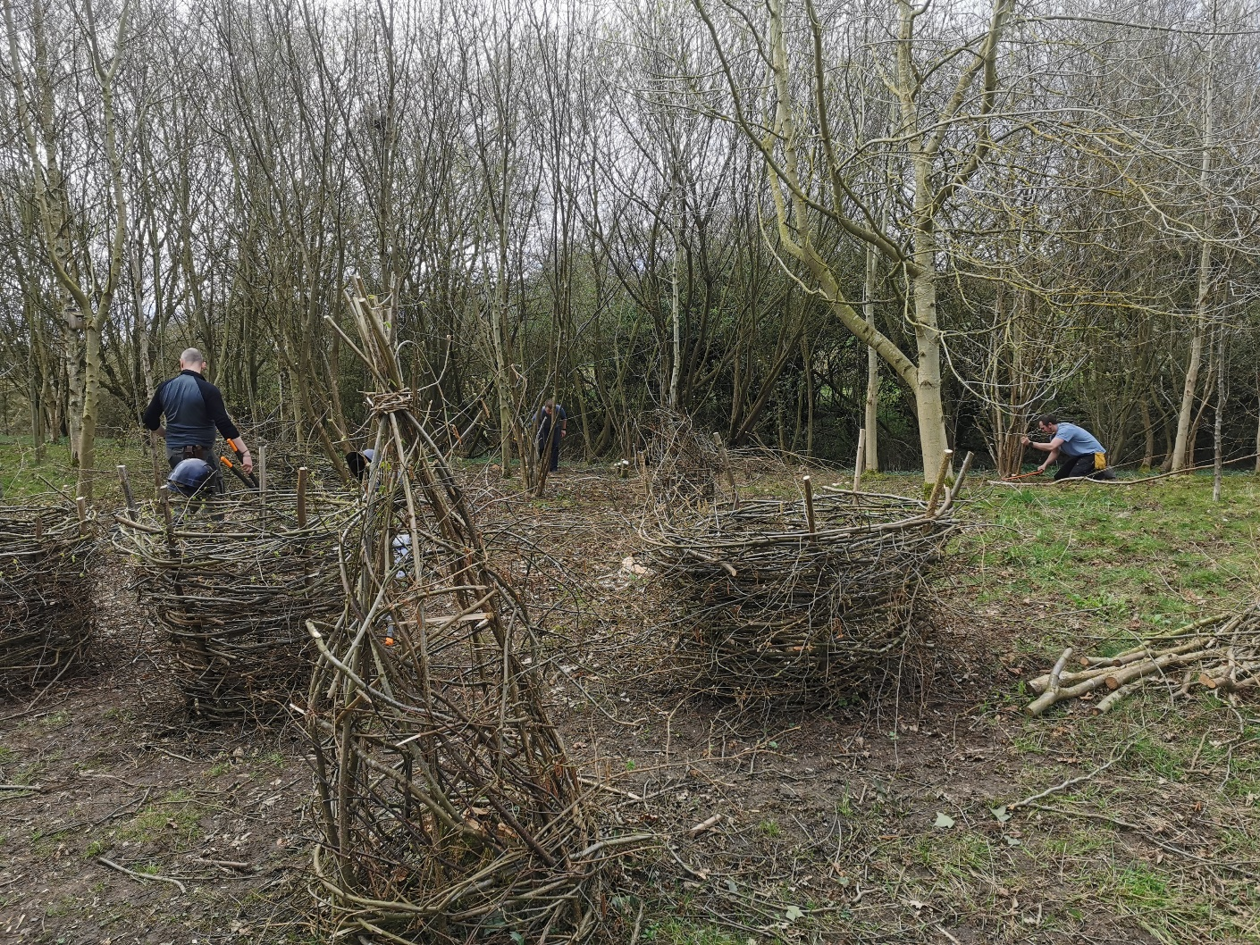
Coppice coupe with our natural woven deer protection, using the brash we harvested from the stools.
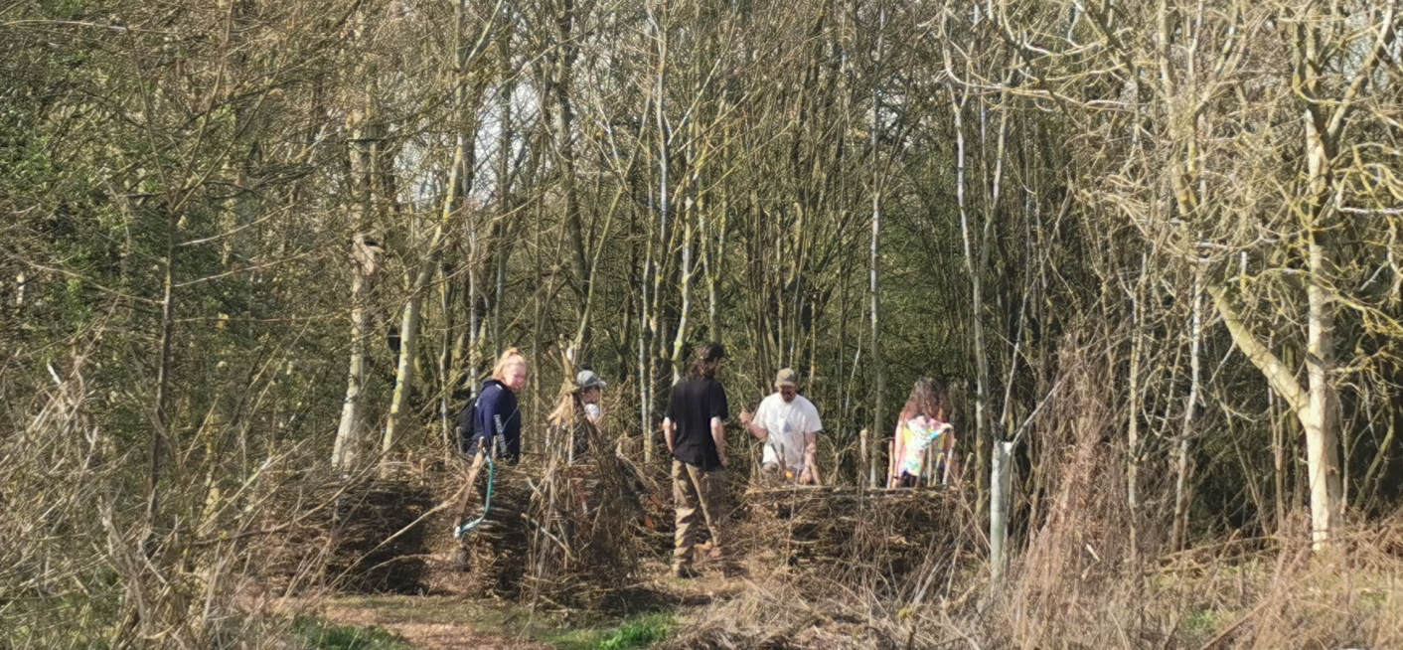
Teaching participants how to weave the coppice baskets

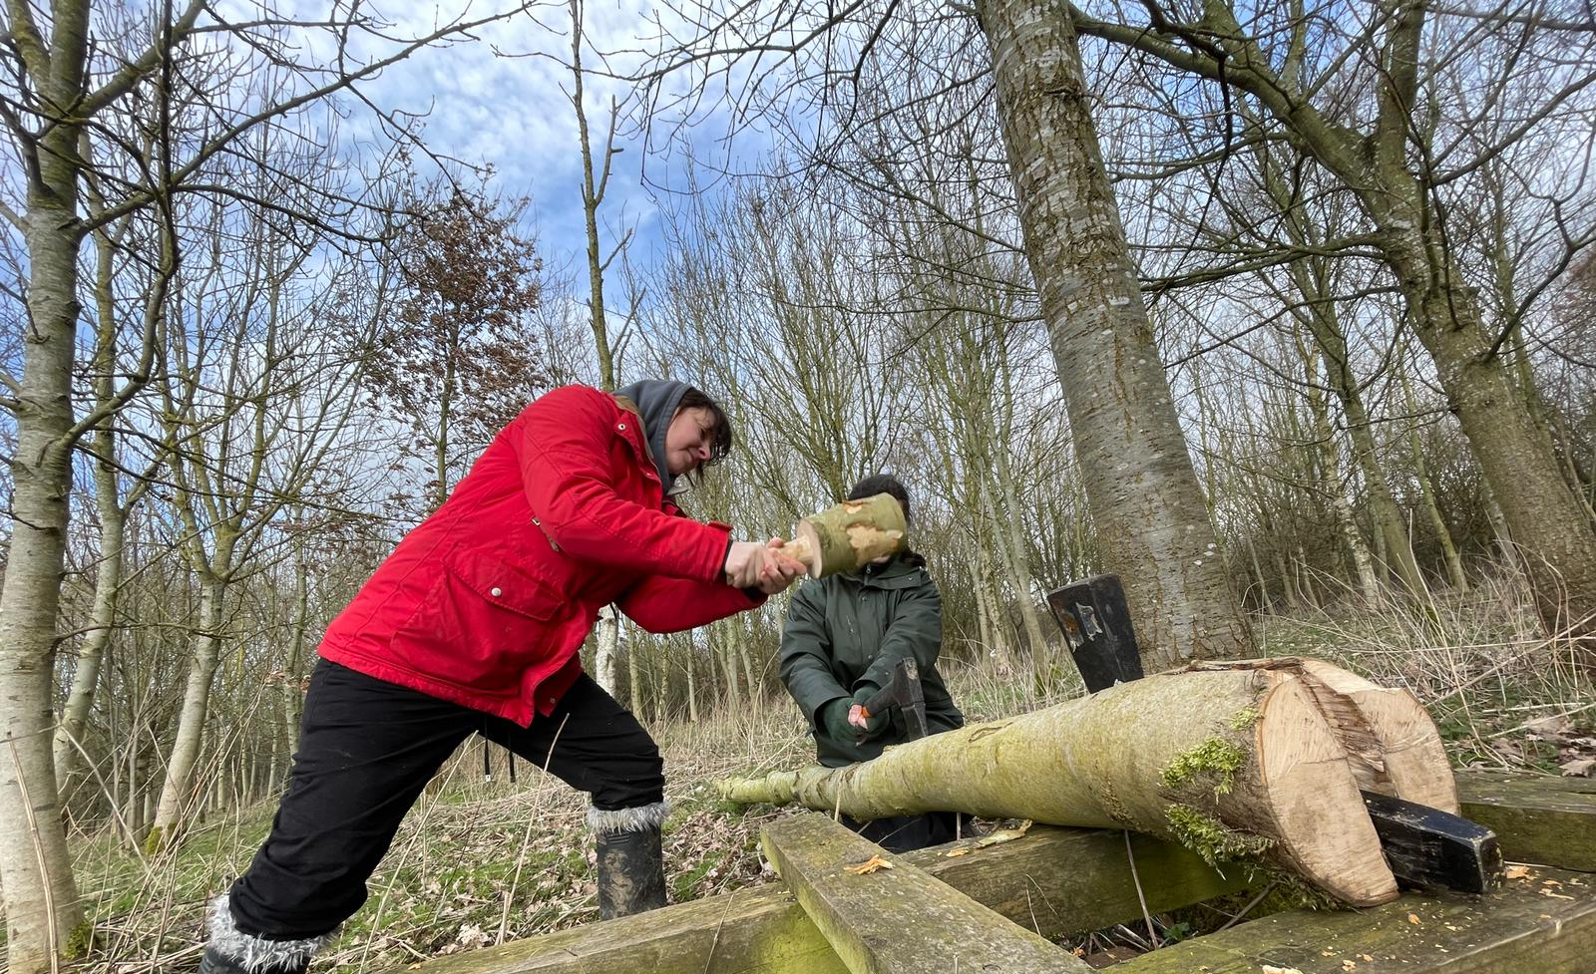
Splitting ash logs using wedges, Jan 2021

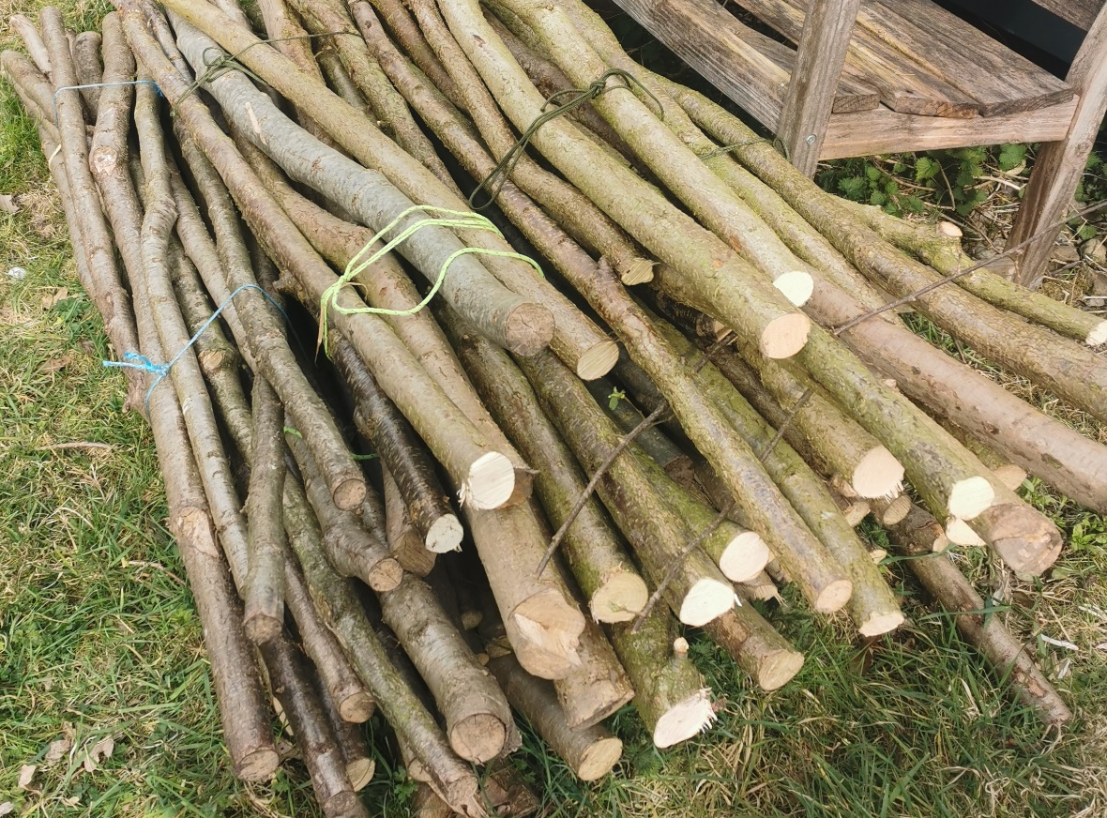

Bundles of Hazel we harvested from the coppice which were used for hedge stakes.
Volunteer Case Study
“I feel strong, gain a sense of satisfaction and find the whole experience therapeutic.”

“I first got in touch with Kindlewoods in November 2020 when I was going through both a tough and transformational time in my life. I found that my low moods and energy levels were becoming worse simply by not seeing or speaking to anyone for days. I was feeling very alone in this ever changing world and started to become concerned about the future. I had no family or friends that I thought I could turn to that would be able to help me. I started with KindleWoods and felt welcome instantly. I volunteered at Thirsk Wellbeing days as well as helped plant trees. We made real Autumn fallen leaf mandalas, clay tree sculptures and Holly wreaths. I could be helpful whilst learning new skills and be creative. Meeting new people and being outdoors even on a bitter cold wet and grey day, feeling happy, content and warm gave a great sense of Wellbeing. We are all there for each other and are helping each other in ways we don’t even realize. The thinning of the woods and the whittling skills are liberating and interesting. I feel strong, gain a sense of satisfaction and find the whole experience therapeutic. I have met a few people at these session’s who are either going through a difficult time or in need to socialize. We have chatted and laughed and had reflective and emotional moments. We do not have to be alone in this world. It’s normal to need other people. This is a big lesson I have learnt. The main feel of the sessions is that of being warmly welcomed and appreciated. Kindlewoods to me is a safe place, where you can be you. I can’t really emphasise enough just what it’s meant to me. It’s easy to sound glib, but it’s the first time I’ve felt like I’ve been part of a community – probably ever”.

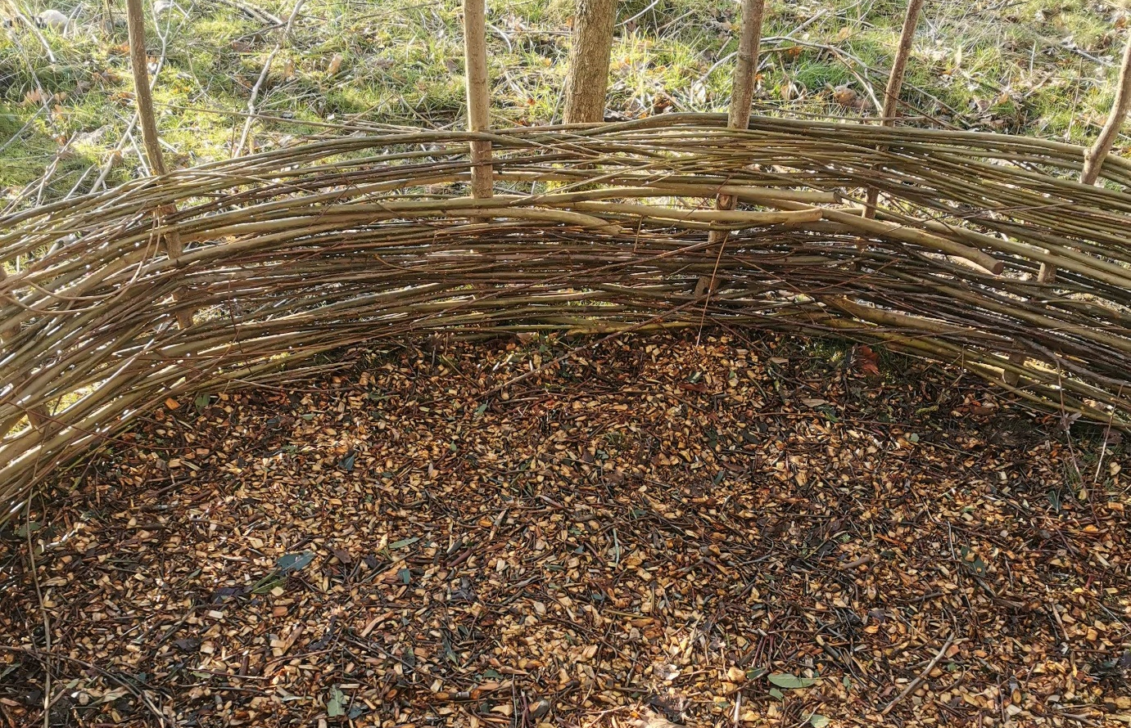
Willow and hazel woven hurdle with woodchip that participants made in the woods as part of the Kindling Community Project
Staff perspective
Our staff have also benefitted from being involved after time isolated;
I first starting working with KindleWoods in 2017 as a wellbeing professional. In 2020, I had personally spent lockdown battling PMDD (premenstrual dysphoric disorder and my social anxiety was becoming more and more of an issue.

It is thanks to this project and working for KindleWoods again that I came back out of hiding and began reintegrating back into the community. This has been a life saver to me and I will be forever grateful for helping me regain my confidence in myself, in my capabilities as a practitioner and in my competence as a human being, able once again to be in the company of others without feeling panicked!
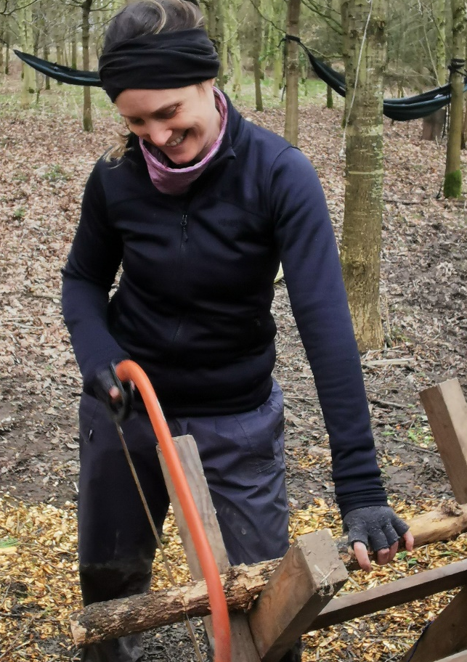
I have seen first hand, and have experienced personally that Kindlewoods is an absolutely essential service. People audibly exhale when they arrive - the tension visibly drops from their shoulders and their faces soften. People who come seeming quiet, introverted and unsure, come out of themselves as they realise that they can do things they never thought they could do in a million years - the growth in skill building, self confidence, trust in their own instincts, ability to listen to and tend to their basic needs is palpable and yet the incredible positive impact of this is hard to put into words!
It is so obvious when people arrive that they need to be there - The sessions are punctuating genuine mental health challenges for people, lifting them from depression and helping them see that there is light in the darkness.
I truly believe these sessions are saving lives.
KindleWoods Woodland Wellbeing Practitioner, Jan 2021

Stakeholder consultation
In August 2020, we surveyed 80 clients and local residents to establish local impact of the pandemic on mental health and to gain feedback on their perception of nature based mental health support. From that survey, 88.6% of survey respondents described the pandemic as having put additional pressure on their mental health, which 80% attributed to reduced social interaction. 96% of survey respondents stated that connecting up with others outdoors in nature in a safe, socially distanced way would be important to either their own, or someone they knows wellbeing in the coming months. People expressed increased anxiety (social anxiety, health anxiety, generalised anxiety and panic disorder) and depression (low mood, suicidal thoughts, self harm) as well as a strong desire to want to connect with others outdoors. Here is a sample of responses;
"I was socially isolated before the pandemic and am even more so now. I've tried to access mental health support from the gp but have so far only been offered a pretty useless, generic, online cbt course. I took part in a kindlewood's session a few years ago, I'd love to come back".
"Definitely. Really important for me to get out of my everyday patterns of thought"
"Yes - for someone who is socially anxious - meeting others in a relaxed and supportive setting would be a useful way of reintegrating back in to normal life. It feels jarring at the moment"
"I've developed deep depression and high anxiety. Having a way of meeting others and easing back into things would be really beneficial"
"I've had an increase in thoughts of self-harm for the last few months, I really need to be back outside with a focus again"
"Yes absolutely, I think people will need to start getting out (safely) and doing new things to help deal with the past few months."
" Yes - I've lost contact with people outside of my family"

